Use this reference to update hubs.

Table of Contents
Ctrl + click to jump to content
About the Hub 1
Update the Hub 3
Configure Suggested Links 4
Customize Hub Navigation 5
Configure Overview 6

About Hubs
In Workday, a Hub is an area providing related, easy-to-access information. Hubs typically feature a unique, left-side navigation panel.
The hubs most commonly used by students are the Academics hub and the Financials hub.
Workday allows institutions to customize hubs and hub navigation panes on a limited basis. Typically, Workday determines the links at the top of the hub navigation pane, while institutions can customize the Suggested Links at the bottom of the hub navigation pane.
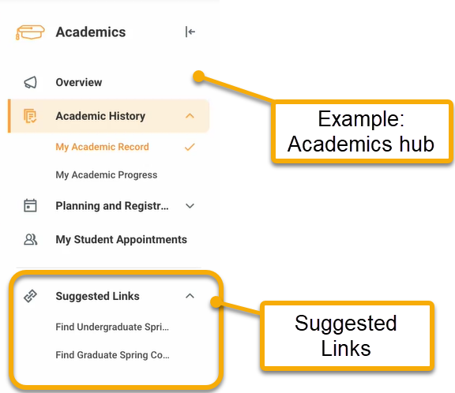

Additionally, institutions may choose to direct students to hubs via the top-left menu or via a link on the dashboard. See both examples here.

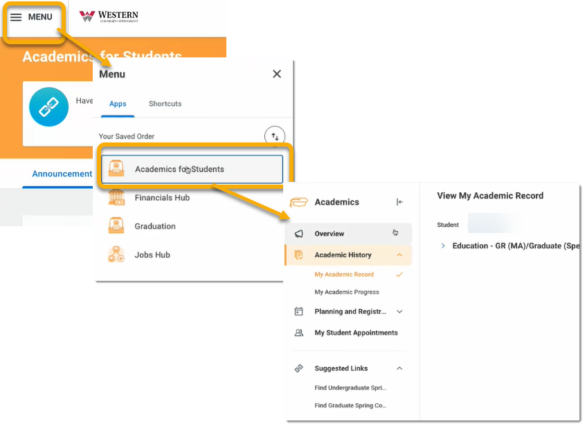

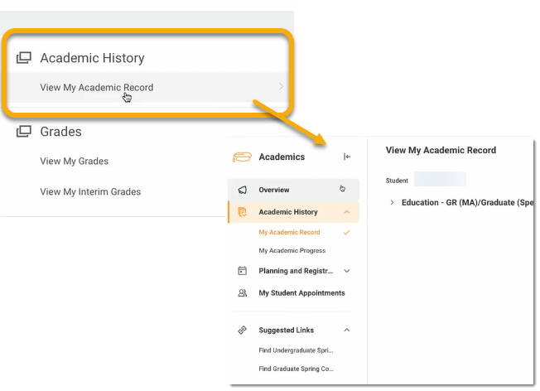

Update the Hub
- In the search bar, locate the Maintain Hubs task.
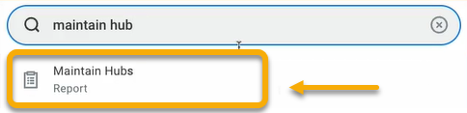
- The Maintain Hubs page will appear with the list of hubs. To update the Academics Hub, locate Academics in the Hub column. From the Actions column in the table, you are able to:
1) Configure suggested links,
2) Customize hub navigation, and
3) Configure overview.

Review this guide for steps on completing each action.

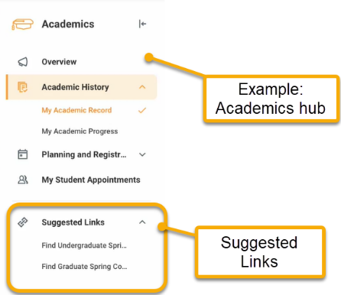
Configure Suggested Links
Suggested links appear at the bottom of the hub navigation pane and require periodic updating, especially at the start of a new academic period. Follow these steps to update suggested links.

- In the Action column, click the corresponding Action drop-down menu and select “Configure Suggested Links”.
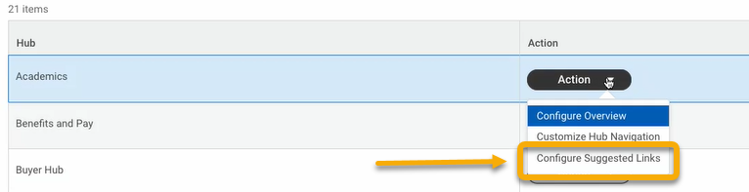

- The Configure Suggested Links window will appear. These links should be updated at the start of a new academic period.
Usually, most links are configured to be visible to all students. This is accomplished using the appropriate Security Group. Conversely, if you want a link to be visible to a limited group, configure the setting using condition rules.

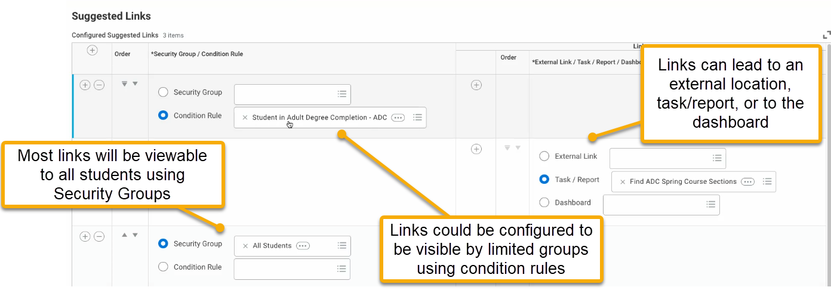

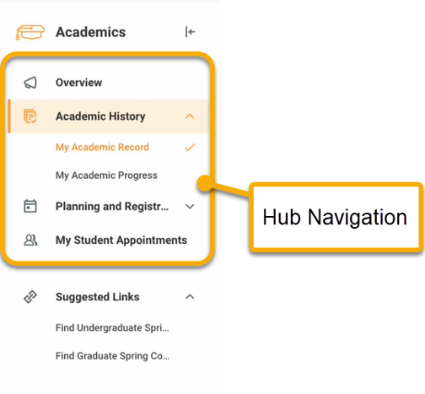
Customize Hub Navigation
The hub navigation controls the navigable items in the top portion of the pane. Users can customize the order of the items displayed, and remove or add items. Follow these steps to customize.

- In the Action column, click the corresponding Action drop-down menu and select “Customize Hub Navigation”.
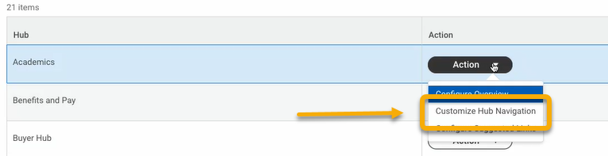
- The Customize Hub Navigation window will appear. A table will display the current navigation items.

Using this table, you can adjust the order of the items, remove an item, or add an item. The available items are pre-set by Workday and cannot be customized.

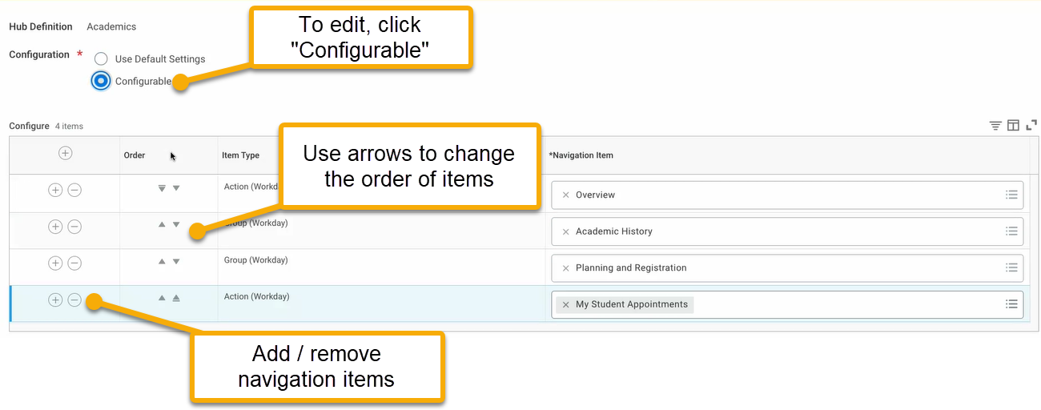

- When finished, click “OK”.

Configure Overview
The hub overview is the initial page users see when they access the hub. The Configure Overview action allows you to customize the information displayed.
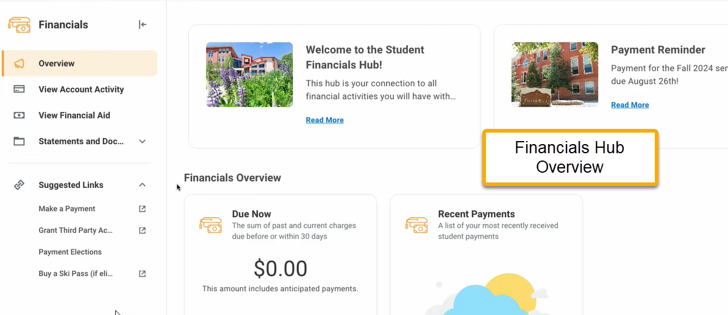
To demonstrate the Configure Overview action, I will use the Financials Hub.

- In the Action column, click the corresponding Action drop-down menu and select “Configure Overview”.
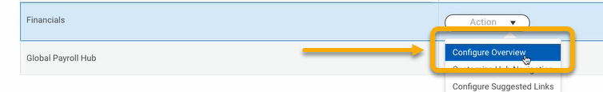

- The Configure Hub by Admin window will appear. A table will display announcements currently on the hub overview.

Announcements may include text, images, or videos. Using the Rule column, they can be visible to all students or a targeted group. From this table, you can also re-arrange the order and set expiration dates to remove announcements on a specific date.
